Kreiranje na nova fiskalna smetka:
--------------------------------------------------------------------------
01,0000,1
`1Produkt 1 А25.00*1.000
1Produkt 2 А10.00*3.000
`1Produkt 3 А25.00*1.000
1Produkt 4 А10.00*5.000
$5
%8

Prikaz vo HEX editor
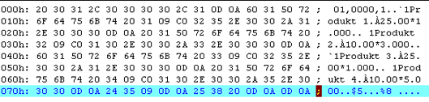
--------------------------------------------------------------------------

Kreiranje na storna smetka:
--------------------------------------------------------------------------
U1,0000,1
#1Produkt 1 А25.00*1.000
1Produkt 2 А10.00*3.000
$5
%V

--------------------------------------------------------------------------
Prikaz vo HEX editor
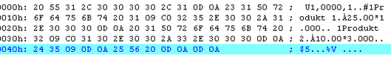
--------------------------------------------------------------------------

Podesuvanje na datum i cas:
--------------------------------------------------------------------------
=01-04-05 15:00

--------------------------------------------------------------------------
Prikaz vo HEX editor
--------------------------------------------------------------------------

Dnevno fiskalno zatvaranje (Dneven Finansiski Izvestaj)
--------------------------------------------------------------------------
E
--------------------------------------------------------------------------
Prikaz vo HEX editor
--------------------------------------------------------------------------

